Guidelines (delete in connection with the completion of the plan of action)
The degree programme quality assurance processes result in an action plan for each individual degree programme, and these form the basis for the degree programmes' development and follow-up in the coming year. One action plan must be drawn up for each study programme – i.e. an action plan for the Bachelor's degree programme in XXX and an action plan for the Master's degree programme in XXX.
Based on discussions in the degree programme board, the head of department prepares a draft of the action plans. To support the ongoing follow-up on actions, the head of department is given responsibility for implementation to the relevant function. Most often, the relevant function here will be head of department and/or a degree programme coordinator. A degree programme board submits the plans of action to the board of studies. The work of the board of studies takes a cross-disciplinary look at all the year's plans of action. The board of studies' discussions support a knowledge exchange and mutual inspiration between the degree programme boards.
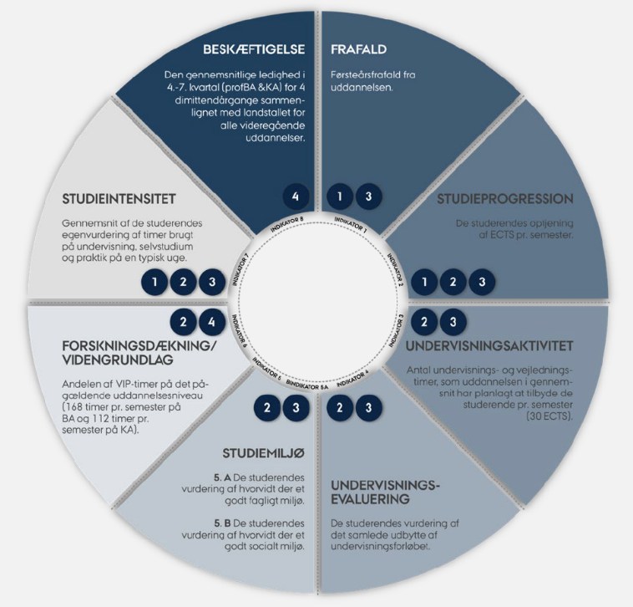
Action plans must be realistic. It must be possible to assess the status of the actions described in the action plan for the subsequent annual status review. It is not a requirement that a prioritised action must be completed and completed within one year, but the action must be initiated. Actions not completed within the past year, and any resulting actions, will be carried over to the current year's plans of action. It is not a requirement to launch initiatives within each of the three components of the sub-policies. What is crucial is that the actions are problem- and development-oriented. The data used in the action plans is a data package containing the indicators for degree programme quality that have been adopted at Aarhus University. The indicator card can be found below. For each indicator, a threshold value has been adopted for:

- satisfactory quality (green)
- quality that requires attention and discussion of possible measures (yellow)
- quality that is critical and where concrete measures need to be taken (red)
Yellow and red indicators must therefore be addressed in the action plan, but it is just as important to address the development over time - in both positive and negative directions, even if the development does not result in a "colour change" but is only a development in numerical value.
Links between the sub-policies and the indicators

Special information concerning the annual status review:
For initiatives initiated in connection with the annual status review, it must be possible to take stock of the subsequent annual status review. It is not a requirement that it must be possible to complete a prioritized action within one year, but the action must be initiated in the quality year in which the indicator requires attention. Actions not completed within the past year, and any derived and adjusted actions, will be carried over to the current year's plans of action. You can read more about the Annual Status Status here.
Concerning programme evaluations:
For actions that are initiated based on a degree programme evaluation, there is a longer time perspective for implementing initiatives and changes. Actions from degree programme evaluations may have grade strategic objectives that are addressed in the vision section of the evaluation report and qualified at the evaluation meeting. The academic environment's visions for the degree programmes and the problem-oriented approach to data material in the analysis sections define the focus areas that we wish to work with in the future. You can read more about programme evaluations here.

Status of completed actions from the last quality year
- brief description of the challenge, action taken and follow-up, and the specific result of the action in question):
Degree programme XXX: Action XXX
…
…

Indicator overview: (optional: attach a screenshot of the the indicatoroverview here)
Insert the indicator number and colour in the first column of the action plan. The link between indicator and sub-policy can be seen in the wheel above.
Sub-policy 1: Getting students off to a good start
1.1 A good start to life as a university student
1.2 Integration into the academic communities
1.3 From pupils to independent university students
Indicator number and colors relevant for the sub-policy area | Focus areas in the 2024 quality year | Actions and follow-up (Ongoing and new actions) | Responsibility | Deadline
Green indicator  Yellow indicator  Red indicator | Brief description of the focus area | Brief and specific description of the actions form and content (3-5 lines) | Name and title/  function/department | Description of the initiative’s deadlines and the planned follow-up
Green indicator  Yellow indicator  Red indicator | Brief description of the focus area | Brief and specific description of the actions form and content (3-5 lines) | Name and title/  function/department | Description of the initiative’s deadlines and the planned follow-up
Green indicator  Yellow indicator  Red indicator | Brief description of the focus area | Brief and specific description of the actions form and content (3-5 lines) | Name and title/  function/department | Description of the initiative’s deadlines and the planned follow-up

Sub-policy 2: High-quality, coherent degree programmes
2.1 Degree programmes based on disciplinary excellence
2.2 Well-designed degree programmes
2.3 Learning through varied learning processes
Indicator number and colors relevant for the sub-policy area | Focus areas in the 2024 quality year | Actions and follow-up (Ongoing and new actions) | Responsibility | Deadline
Green indicator  Yellow indicator  Red indicator | Brief description of the focus area | Brief and specific description of the actions form and content (3-5 lines) | Name and title/  function/department | Description of the initiative’s deadlines and the planned follow-up
Green indicator  Yellow indicator  Red indicator | Brief description of the focus area | Brief and specific description of the actions form and content (3-5 lines) | Name and title/  function/department | Description of the initiative’s deadlines and the planned follow-up
Green indicator  Yellow indicator  Red indicator | Brief description of the focus area | Brief and specific description of the actions form and content (3-5 lines) | Name and title/  function/department | Description of the initiative’s deadlines and the planned follow-up

Sub-policy 3: Motivational teaching and learning environments
3.1 Engaged teaching
3.2 Support in learning processes
3.3 Physical environment must stimulate learning and well-being
Indicator number and colors relevant for the sub-policy area | Focus areas in the 2024 quality year | Actions and follow-up (Ongoing and new actions) | Responsibility | Deadline
Green indicator  Yellow indicator  Red indicator | Brief description of the focus area | Brief and specific description of the actions form and content (3-5 lines) | Name and title/  function/department | Description of the initiative’s deadlines and the planned follow-up
Green indicator  Yellow indicator  Red indicator | Brief description of the focus area | Brief and specific description of the actions form and content (3-5 lines) | Name and title/  function/department | Description of the initiative’s deadlines and the planned follow-up
Green indicator  Yellow indicator  Red indicator | Brief description of the focus area | Brief and specific description of the actions form and content (3-5 lines) | Name and title/  function/department | Description of the initiative’s deadlines and the planned follow-up

Sub-policy 4: Highly qualified graduates with relevant competencies
4.1 Competencies that fulfil society's needs
4.2 Interaction with stakeholders in the labour market
4.3 Contact with employers ensures relevance
Indicator number and colors relevant for the sub-policy area | Focus areas in the 2024 quality year | Actions and follow-up (Ongoing and new actions) | Responsibility | Deadline
Green indicator  Yellow indicator  Red indicator | Brief description of the focus area | Brief and specific description of the actions form and content (3-5 lines) | Name and title/  function/department | Description of the initiative’s deadlines and the planned follow-up
Green indicator  Yellow indicator  Red indicator | Brief description of the focus area | Brief and specific description of the actions form and content (3-5 lines) | Name and title/  function/department | Description of the initiative’s deadlines and the planned follow-up
Green indicator  Yellow indicator  Red indicator | Brief description of the focus area | Brief and specific description of the actions form and content (3-5 lines) | Name and title/  function/department | Description of the initiative’s deadlines and the planned follow-up

